task0_codespace_create_and_list.png

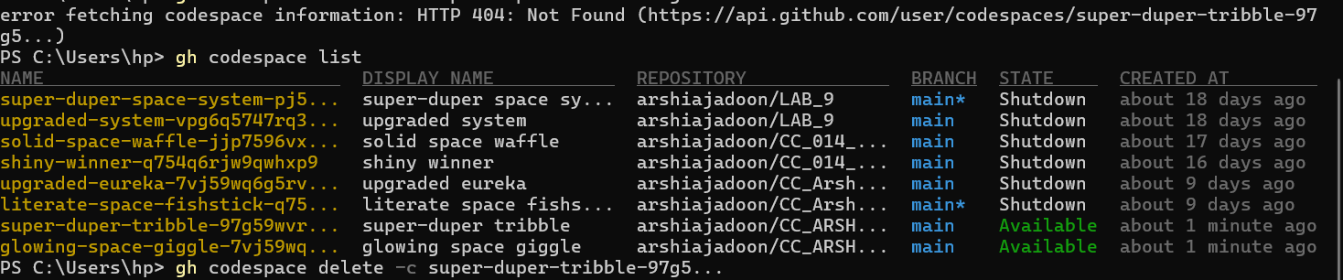

task0_codespace_ssh_connected.png



task1_project_directory.png

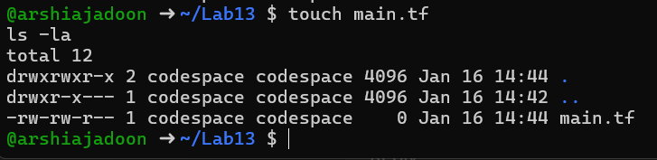

task1_main_tf.png

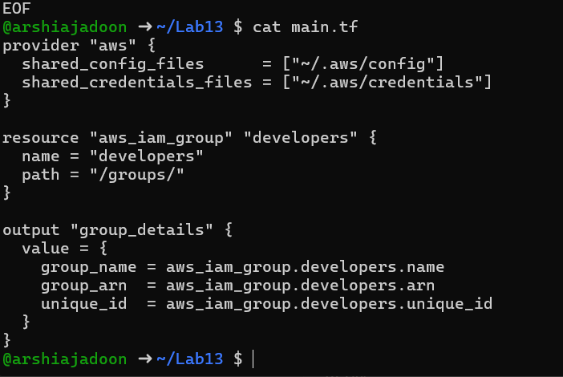

task1_terraform_init.png

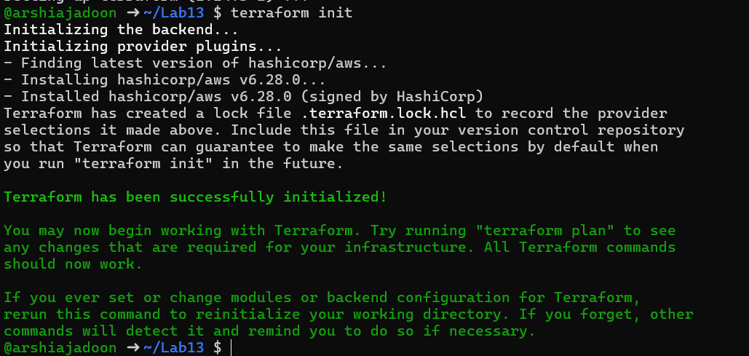

task1_terraform_apply.png-

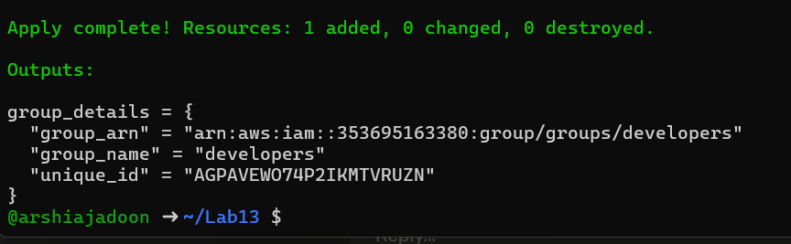

task1_terraform_output.png

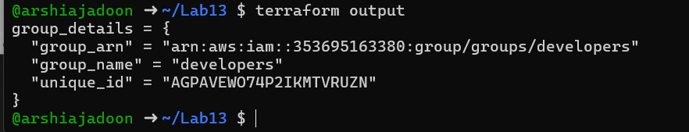

task1_aws_console_group.png



task2_main_tf_user.png

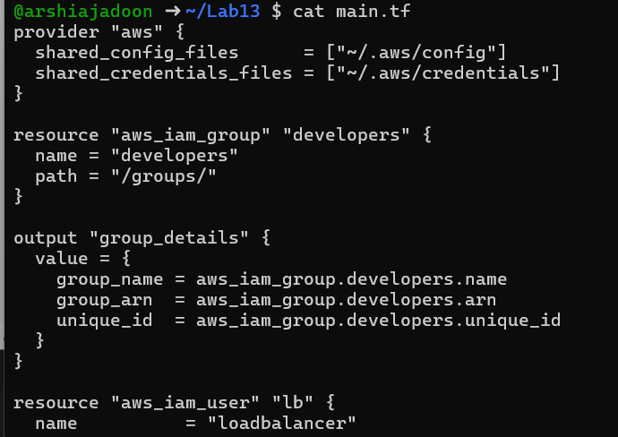

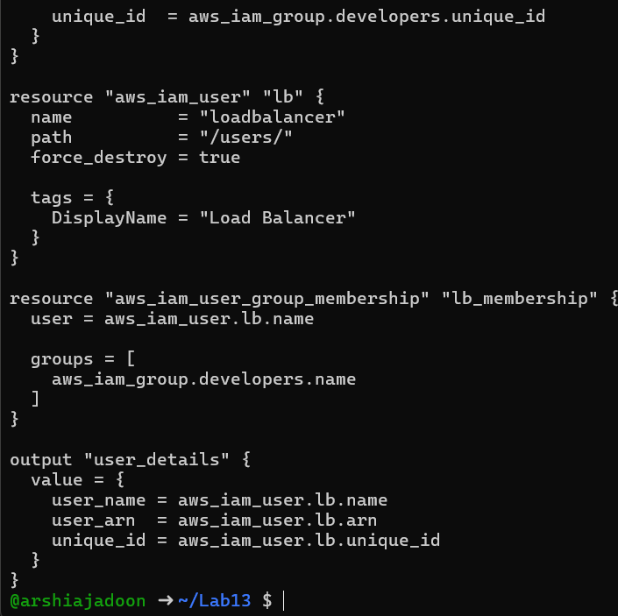

task2_terraform_apply.png

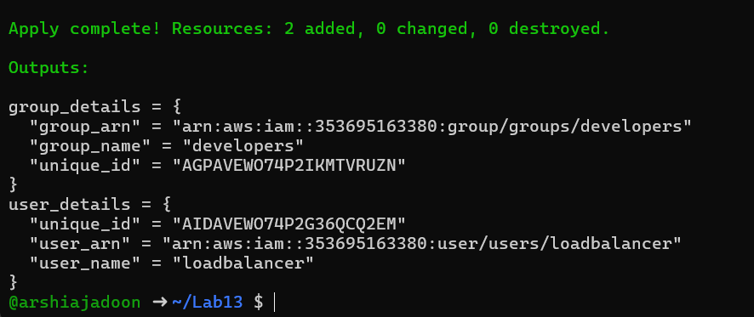

task2_terraform_output.png

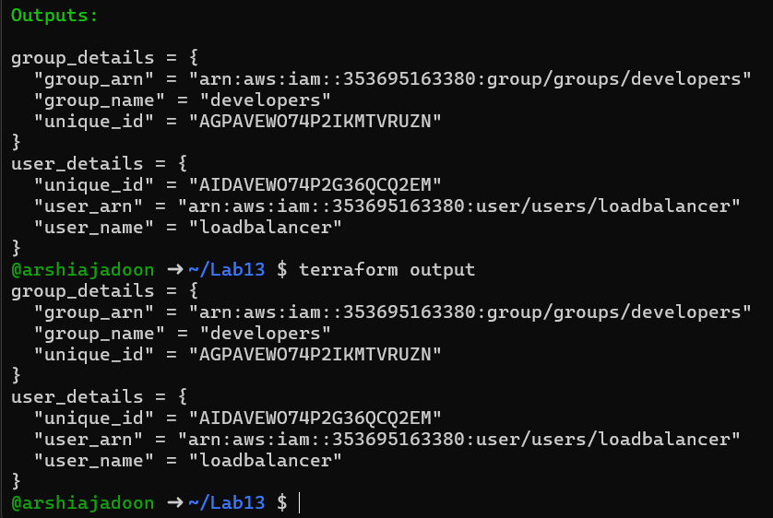

task2_aws_console_user.png

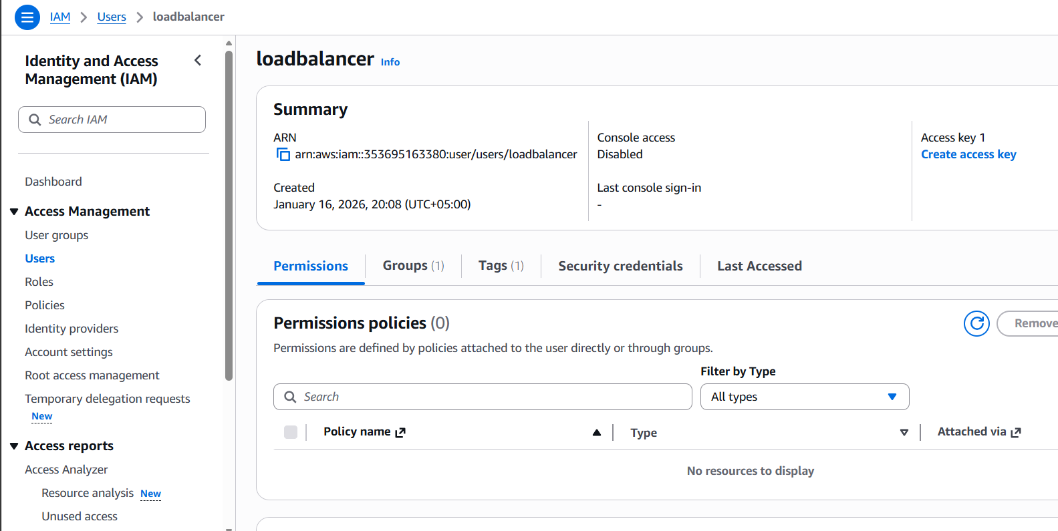

task2_aws_console_user_groups.png

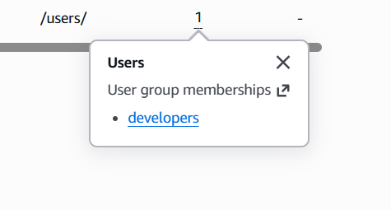

task3_main_tf_policies.png

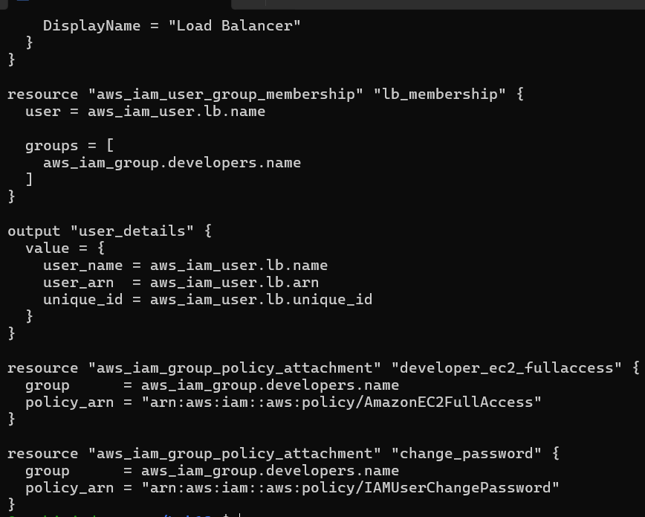

task3_terraform_apply.png

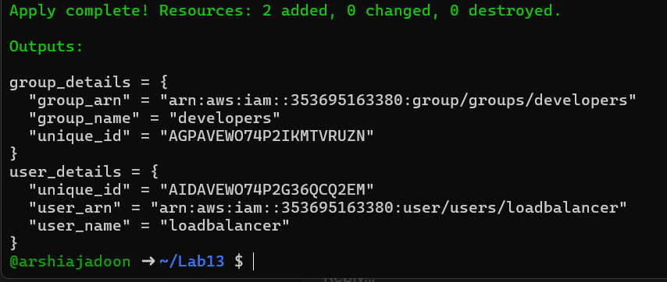

task3_aws_console_policies.png

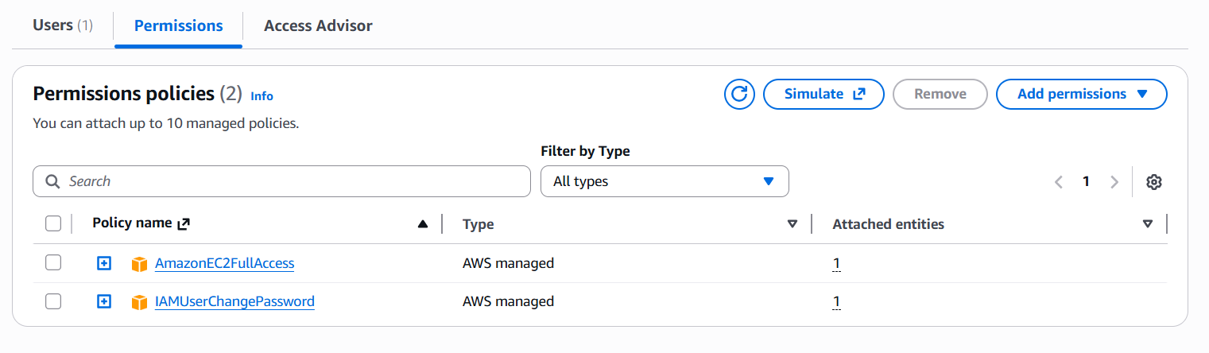

task4_variables_tf.png

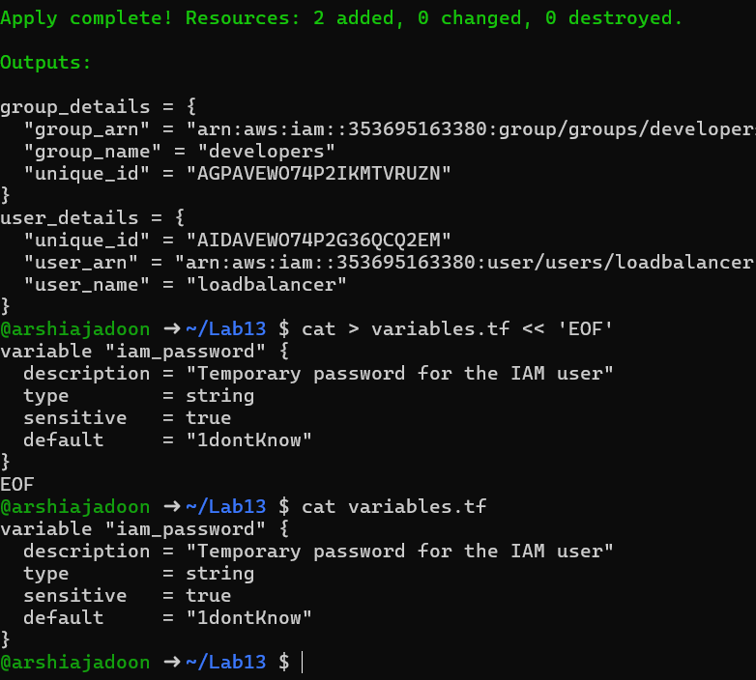

task4_create_login_script.png

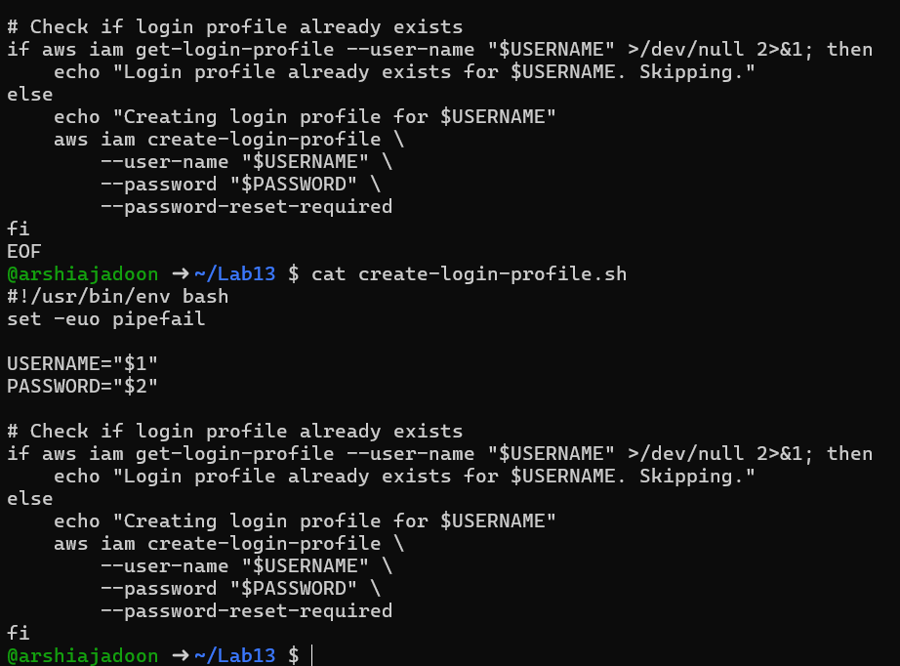

task4_chmod_script.png

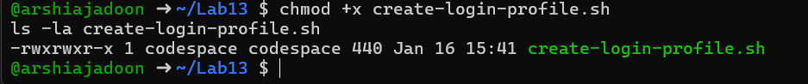

task4_main_tf_login_profile.png

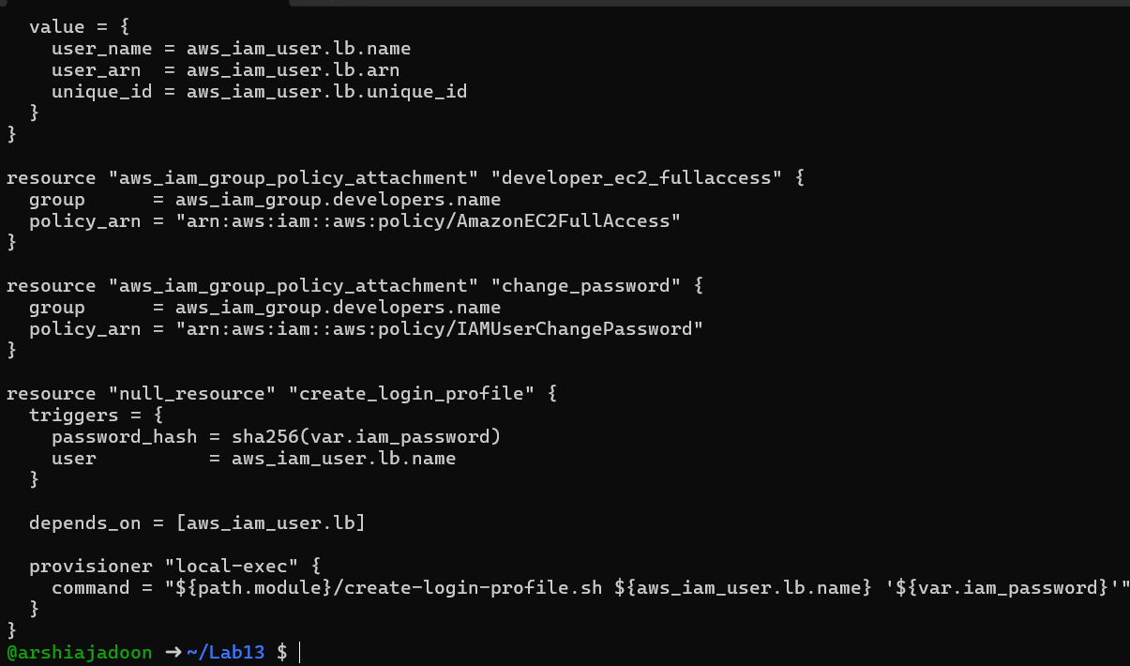

task4_terraform_apply.png

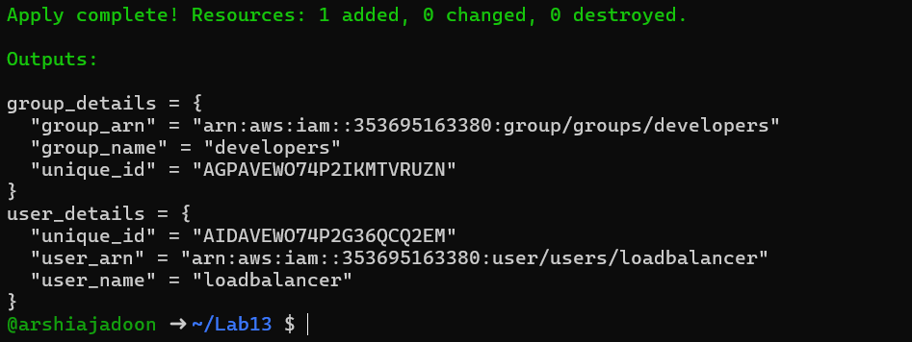

task4_aws_cli_verify.png

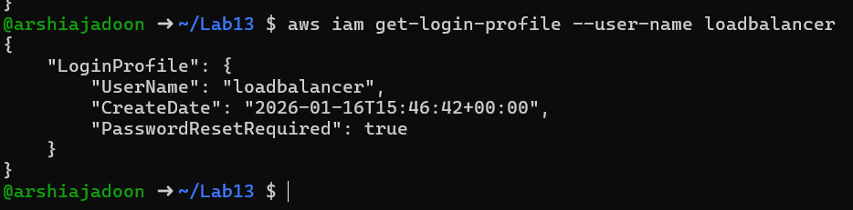

task5_main_tf_access_keys.png

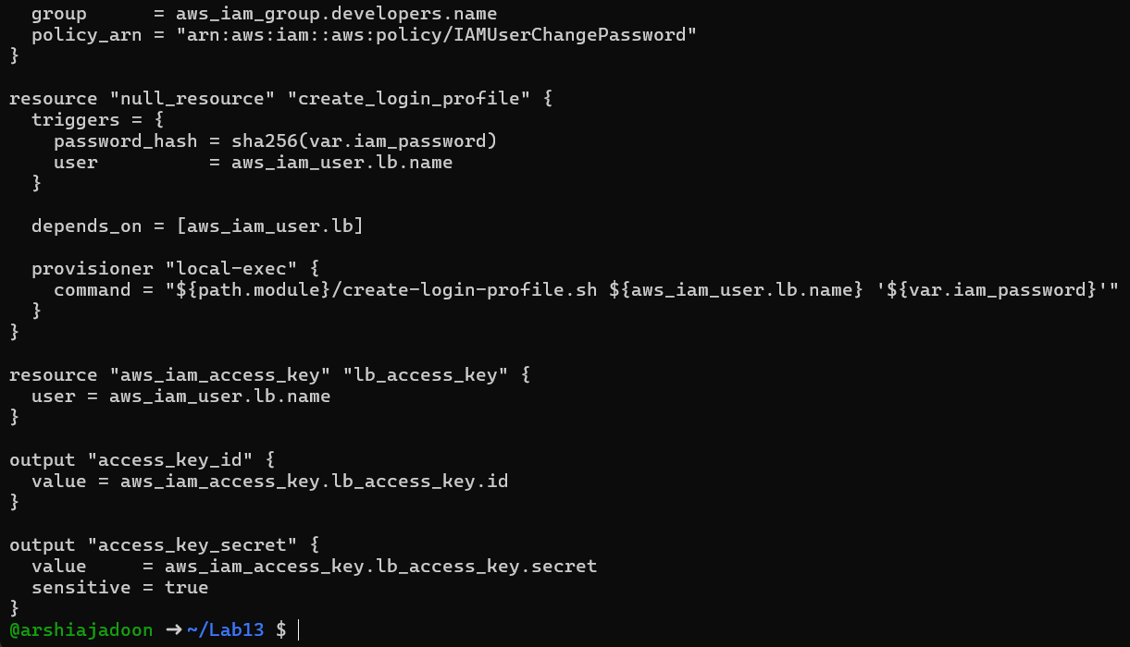

task5_terraform_apply.png

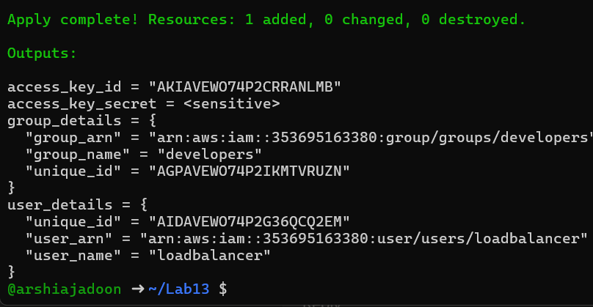

task5_terraform_output.png

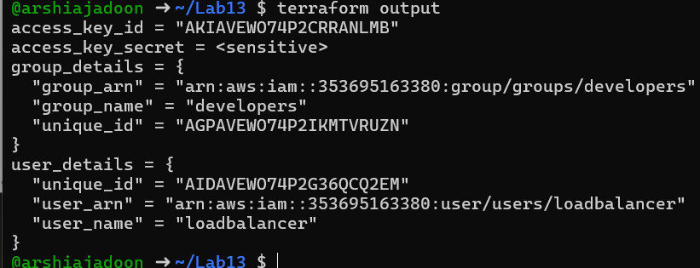

task5_tfstate_secret. Png

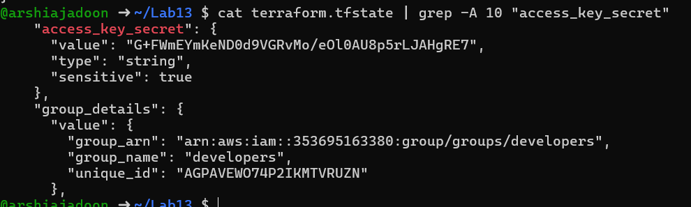

task5_aws_console_access_keys. png

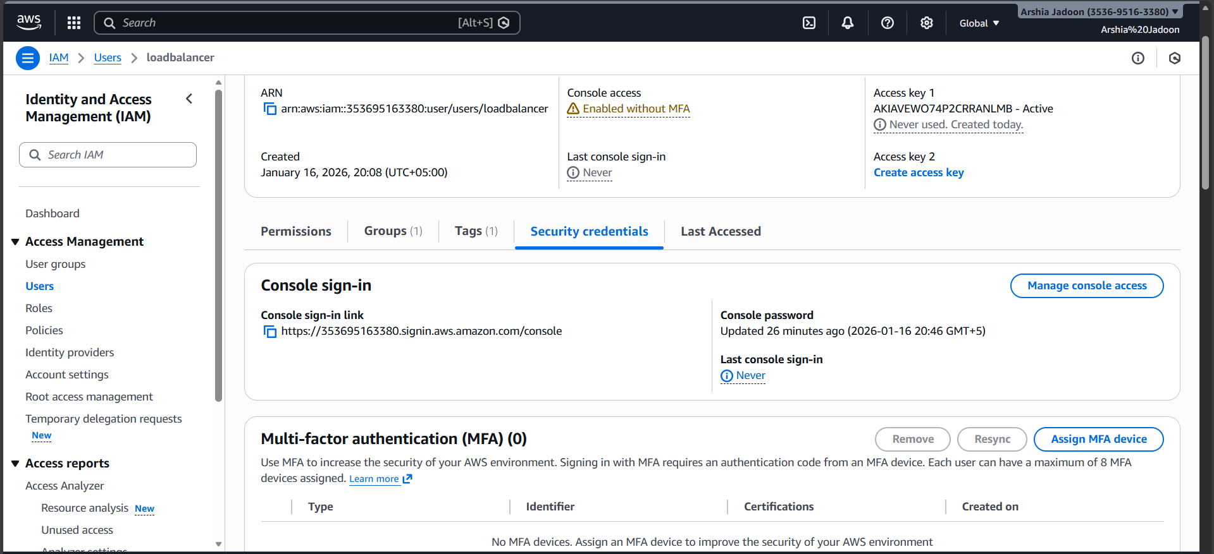

task6_s3_bucket_create.png

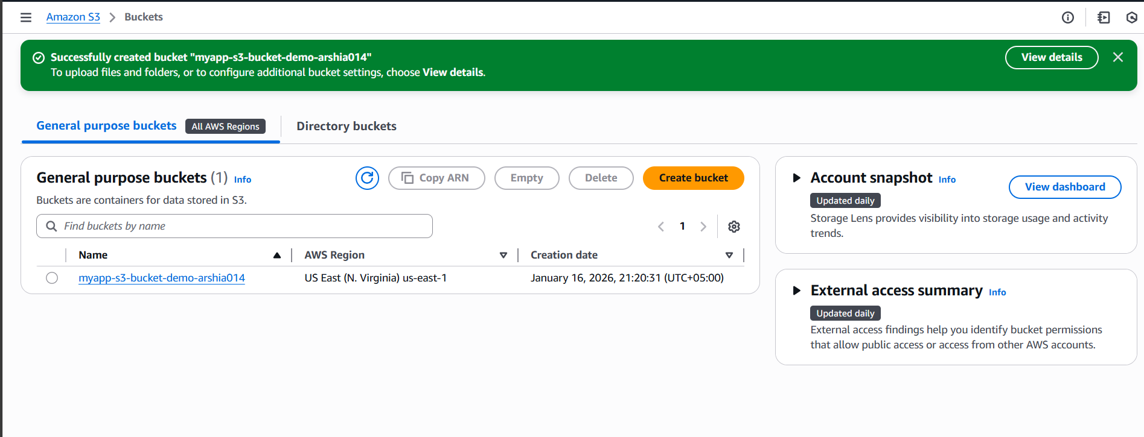

task6_s3_bucket_versioning.png

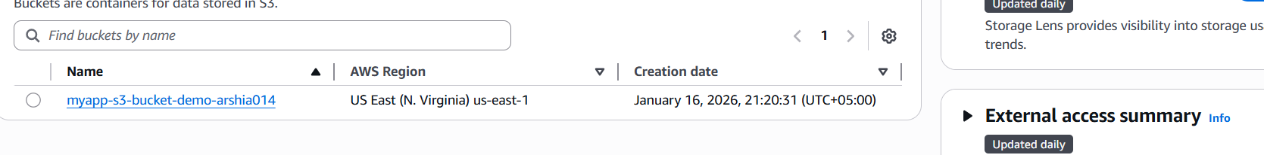

task6_main_tf_backend.png

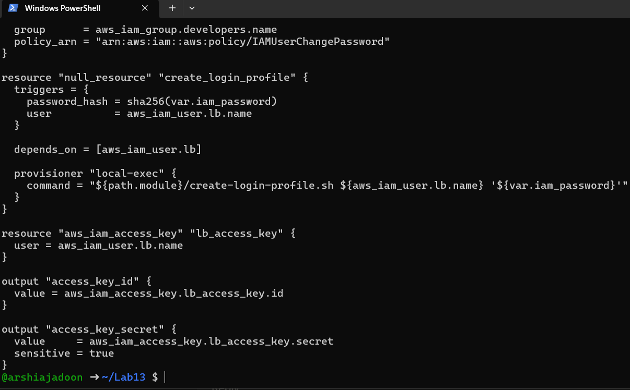

task6_terraform_init_migrate.png

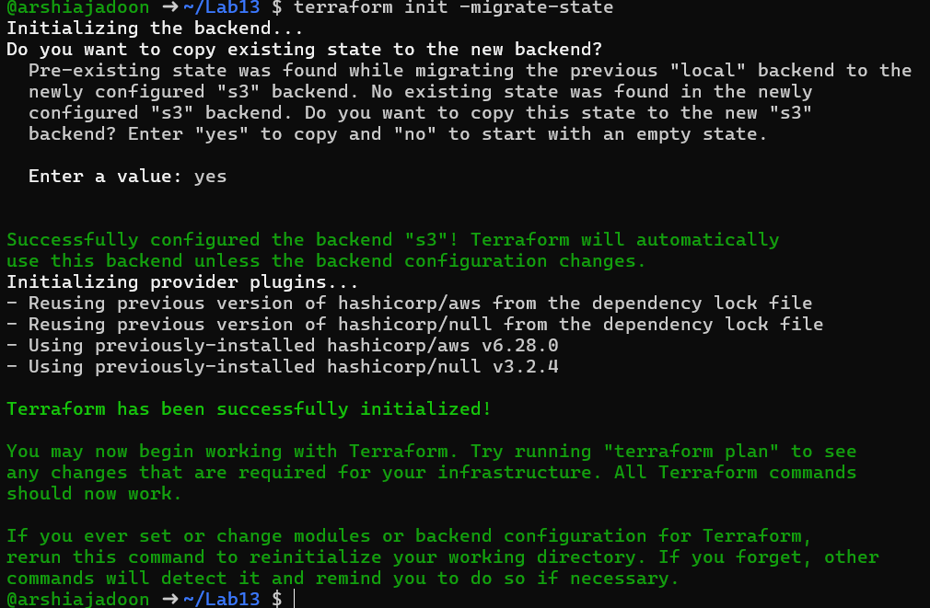

task6_terraform_apply.png

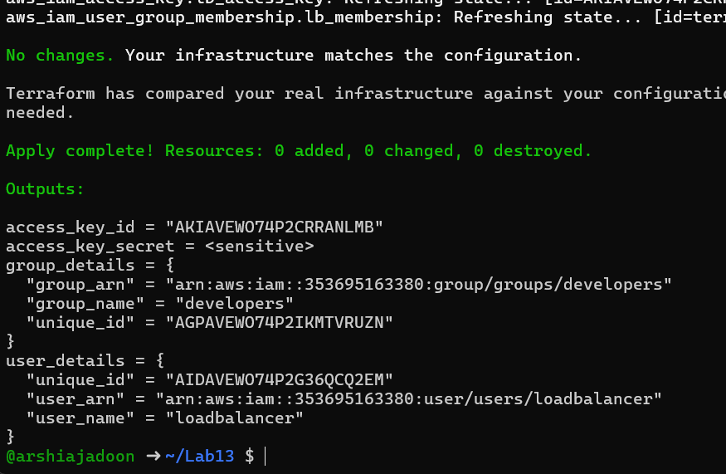

task6_s3_tfstate_file.png

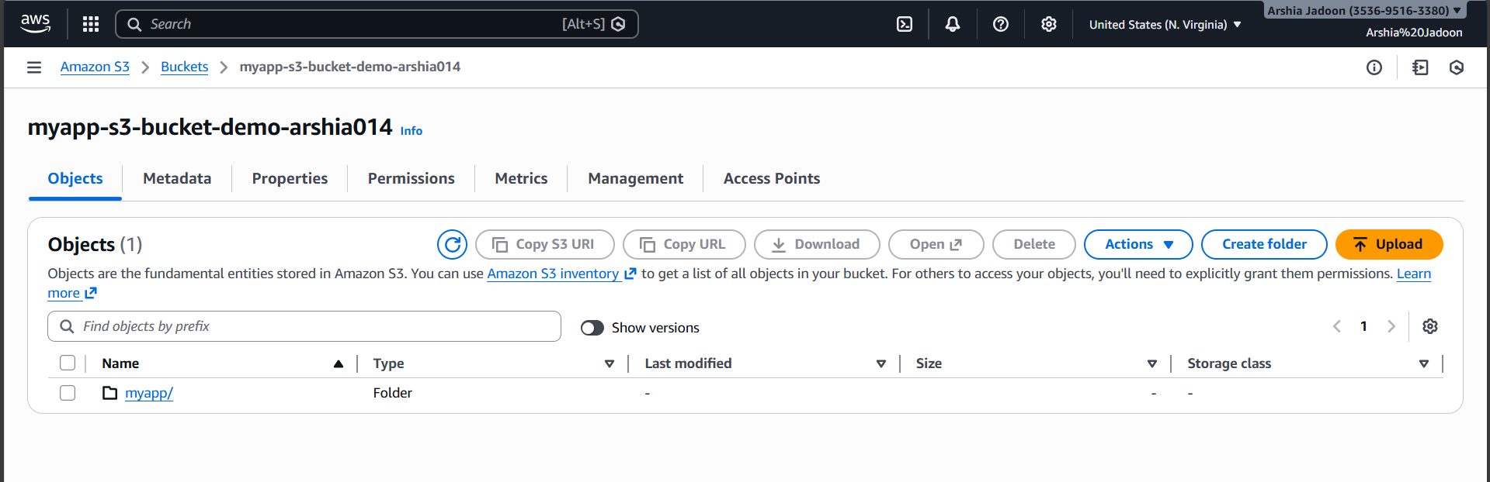

task6_local_state_backup.png

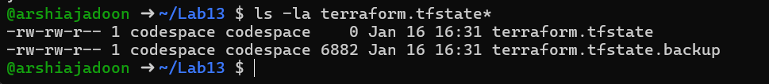

task6_terraform_destroy.png

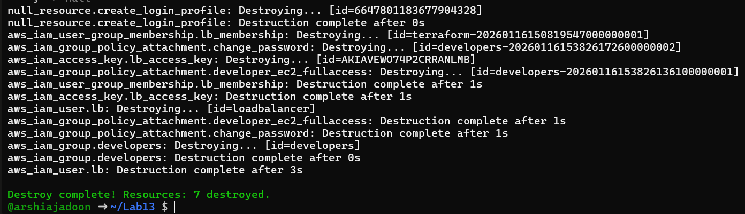

task6_s3_tfstate_destroyed. Png

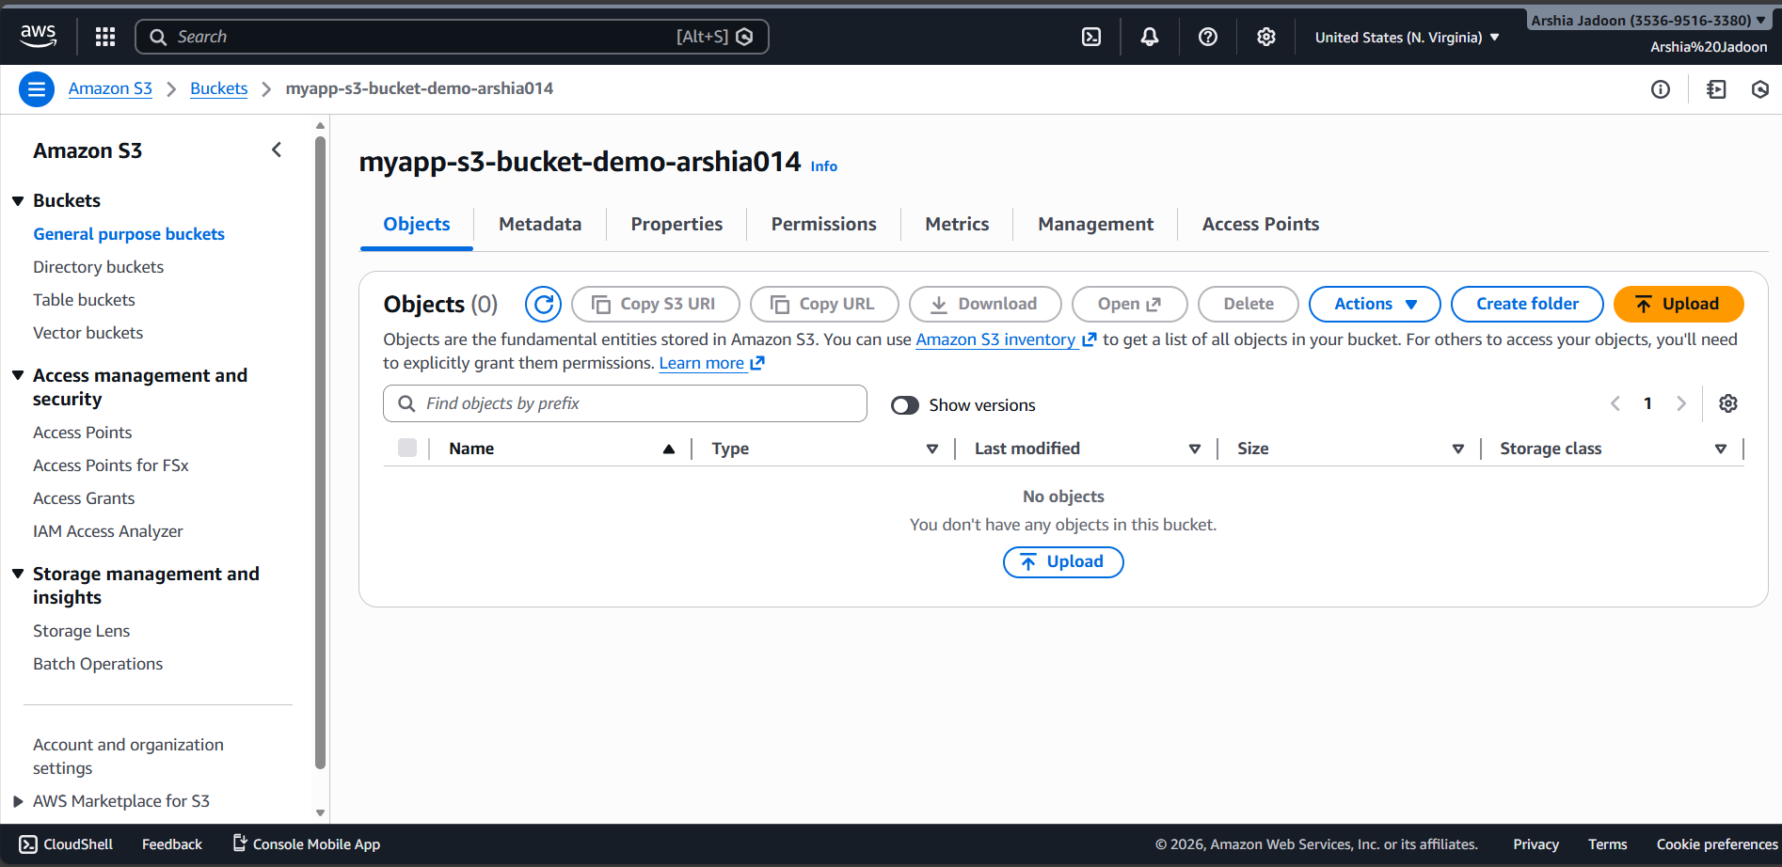

task7_locals_tf.png

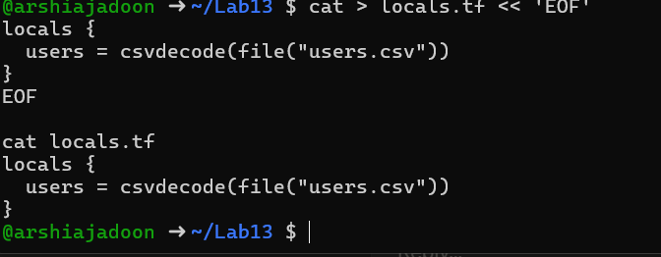

task7_users_csv.png

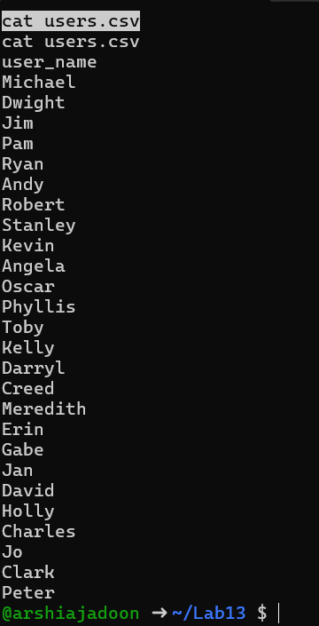

task7_main_tf_multiple_users.png

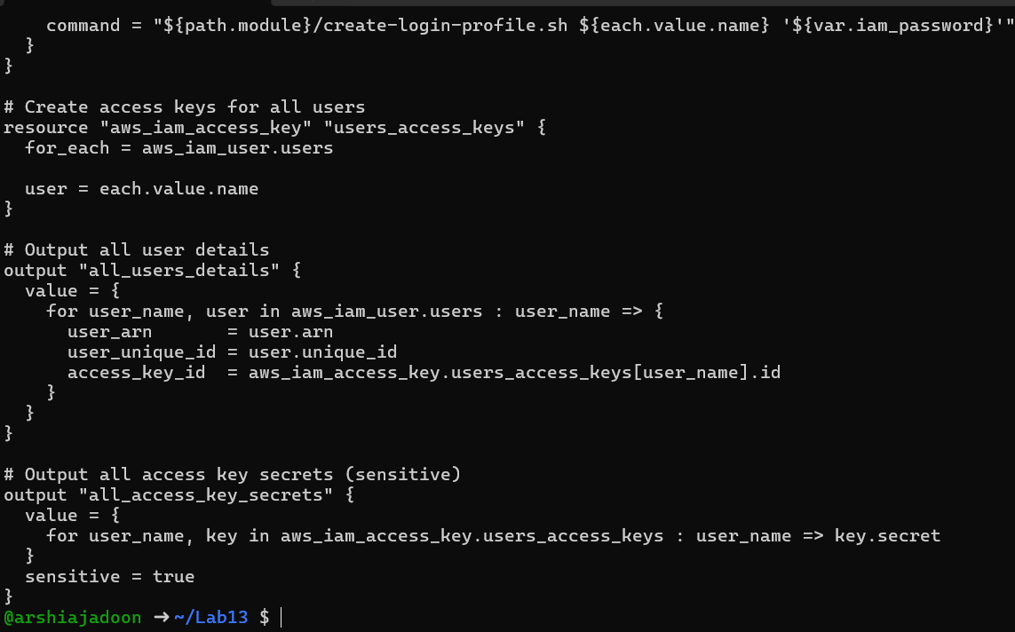

task7_terraform_init.png

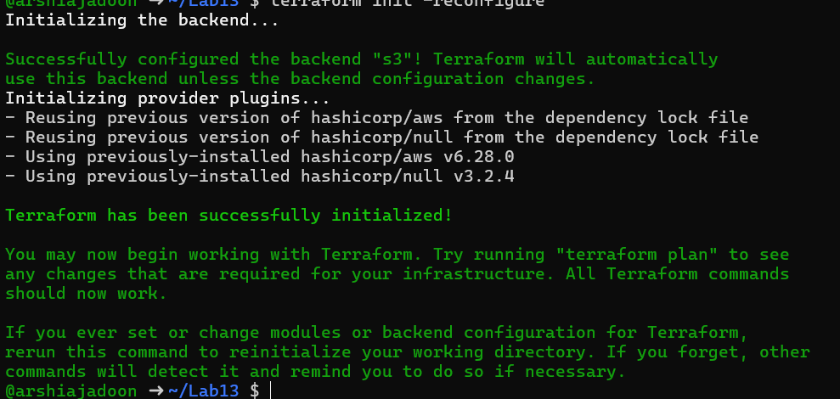

task7_terraform_apply.png

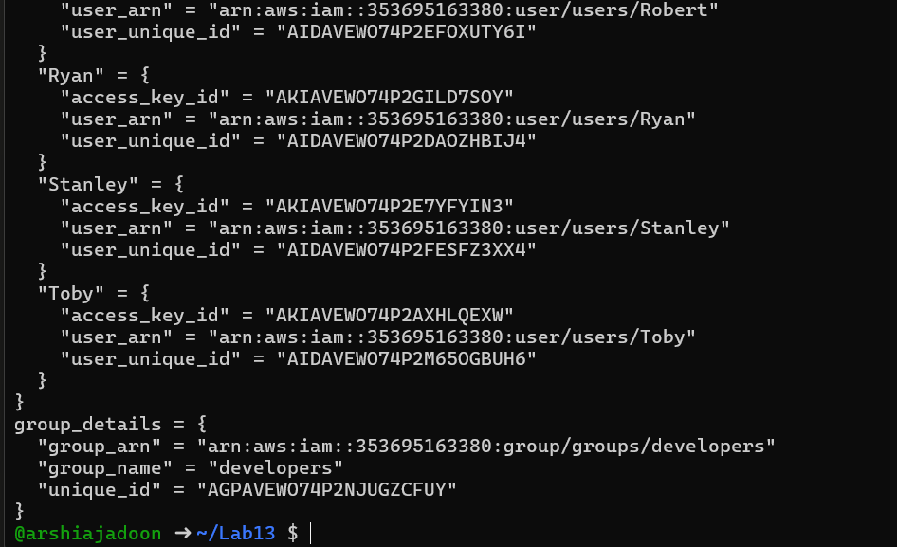

task7_terraform_output.png

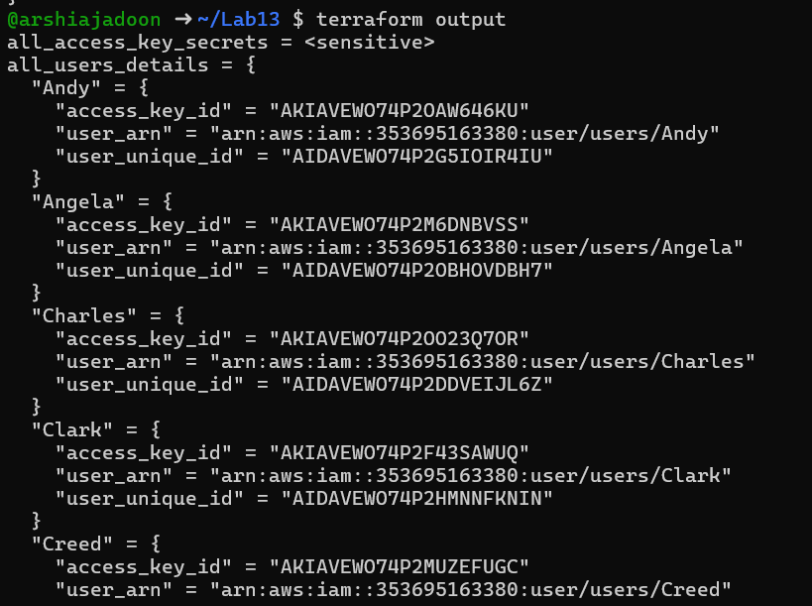

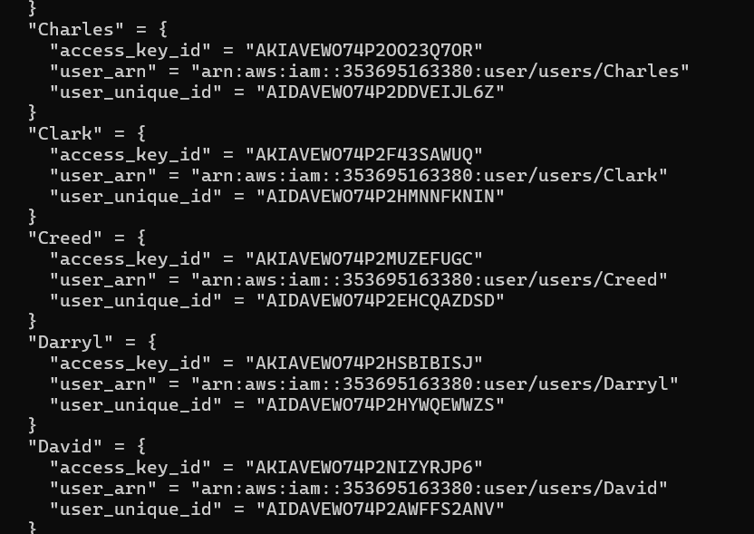

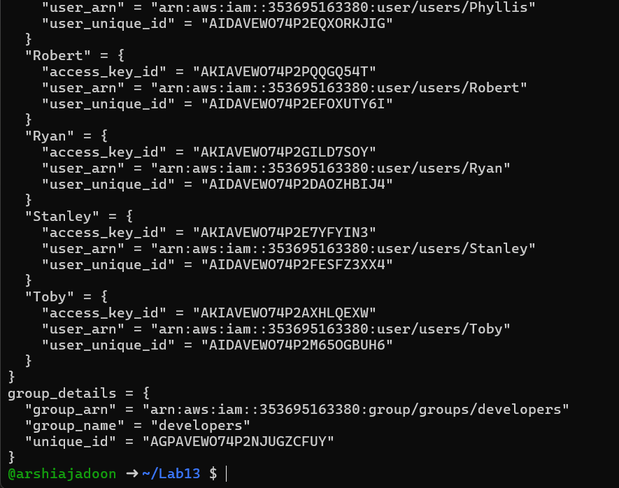

task7_tfstate_secrets. Png



task7_aws_console_all_users. Png

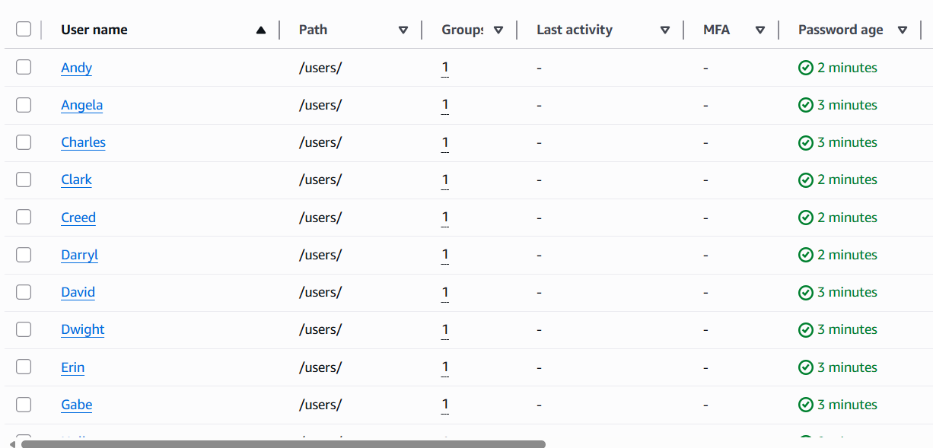

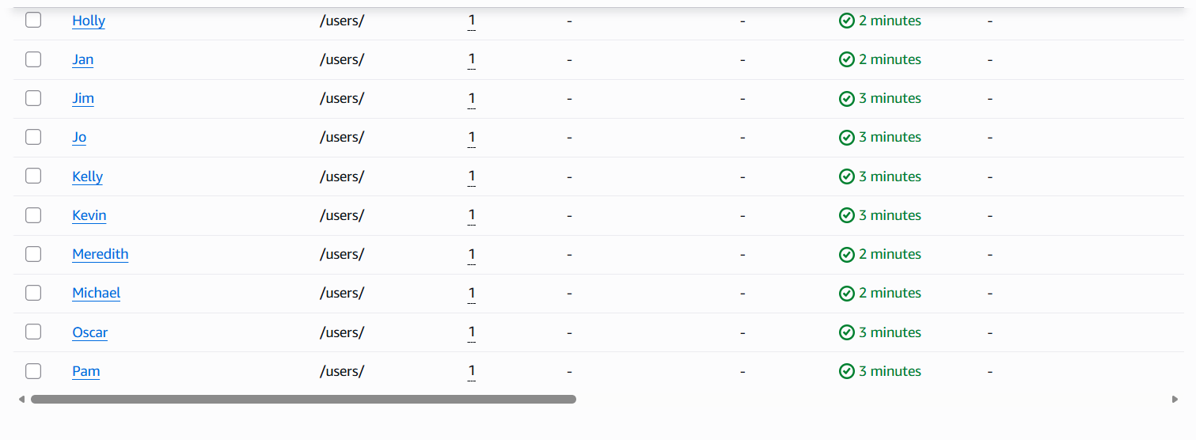

task7_aws_console_group_members. Png

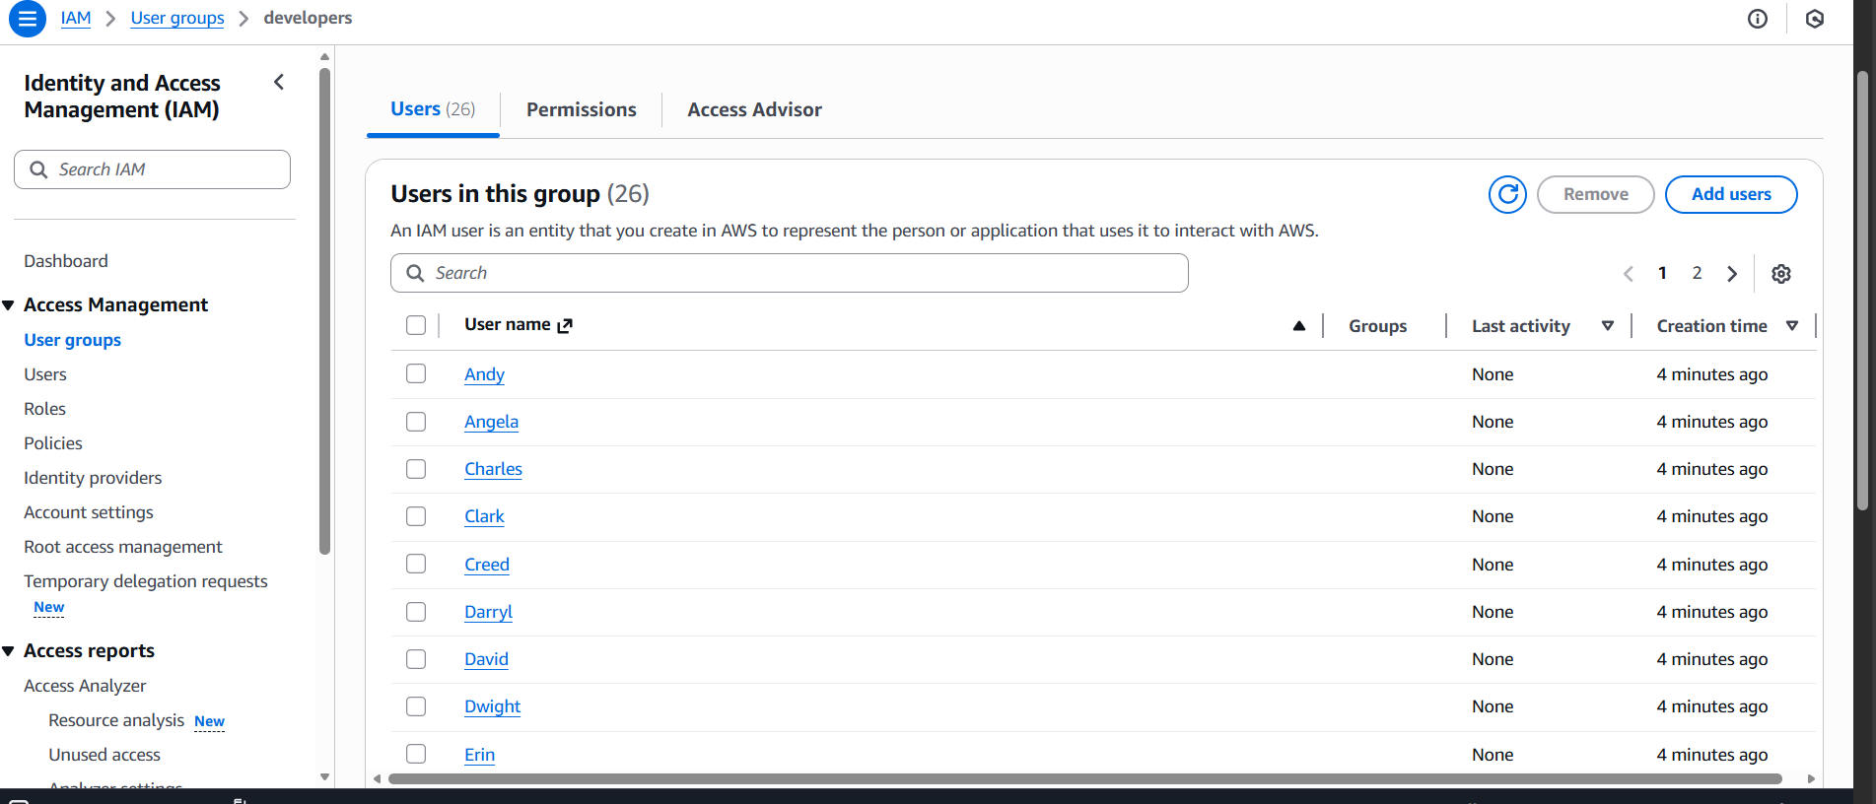

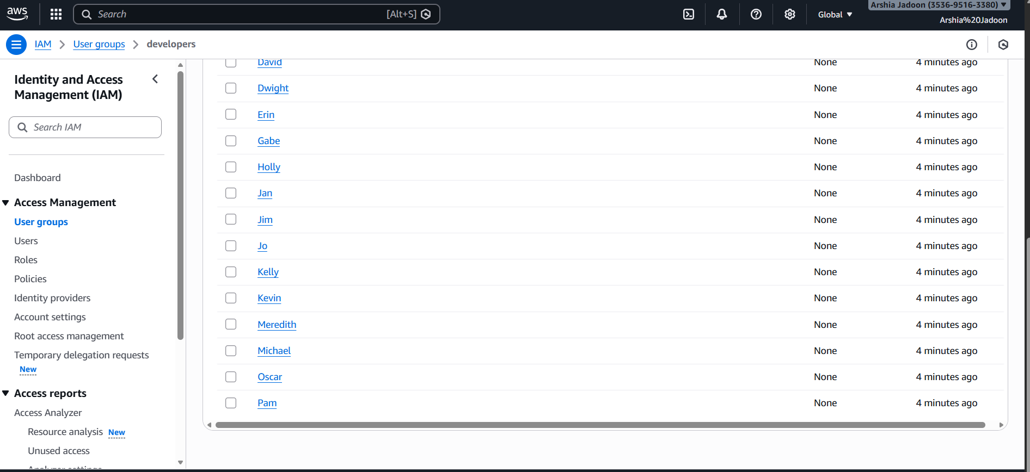

task7_aws_console_user_access_key.png

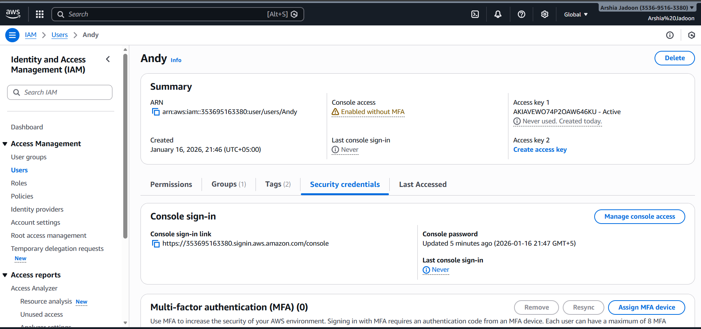

task7_s3_tfstate_multiple_users.png

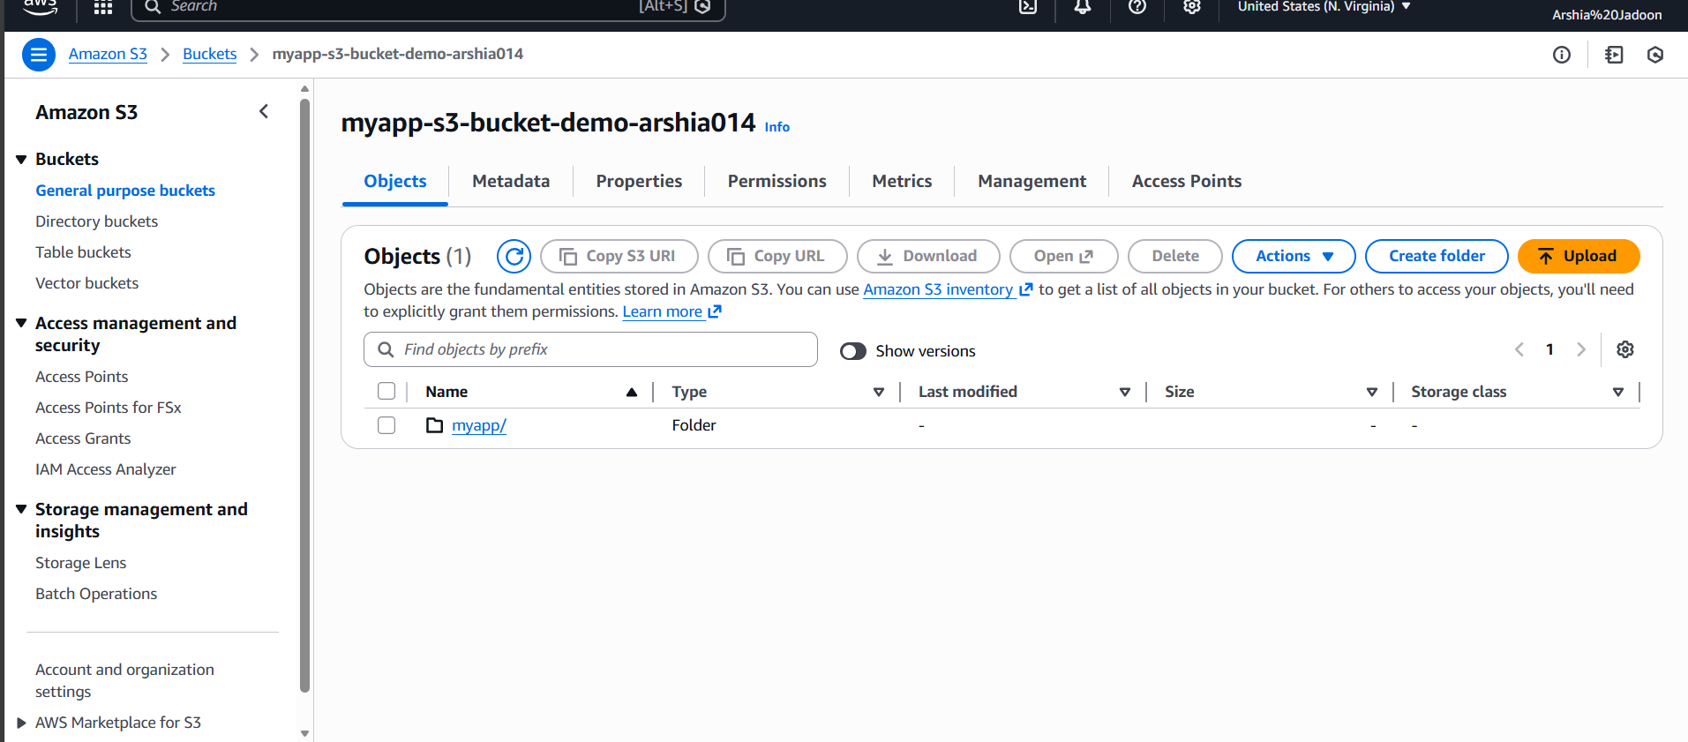

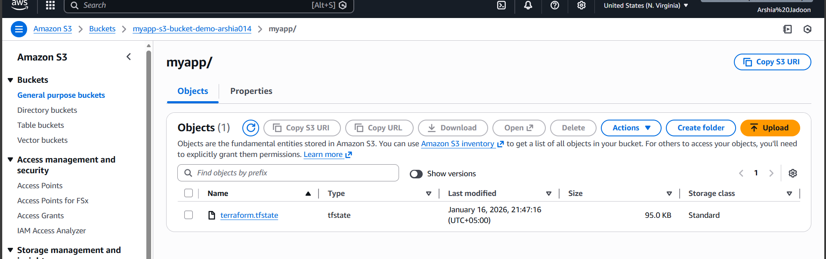

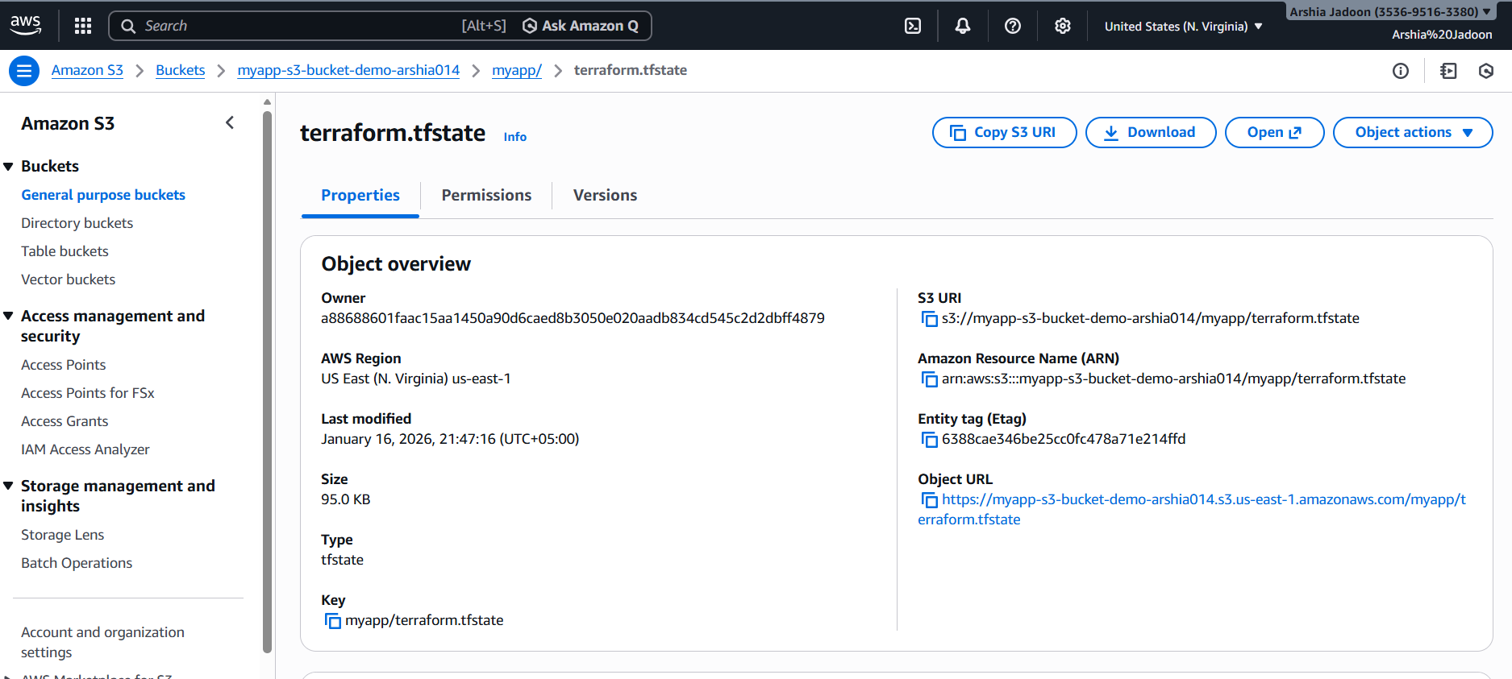

cleanup_destroy_complete.png

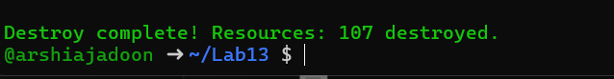

cleanup_aws_console_users_deleted.png

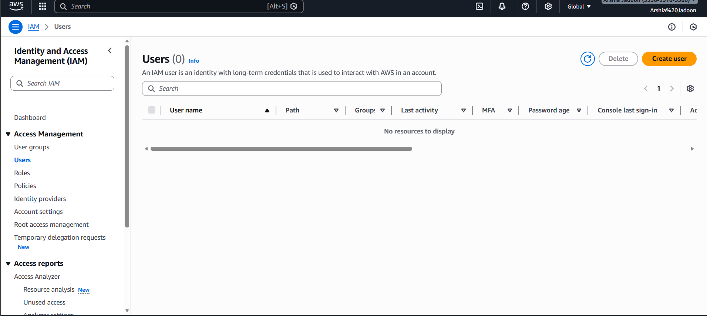

cleanup_aws_console_group_deleted.png

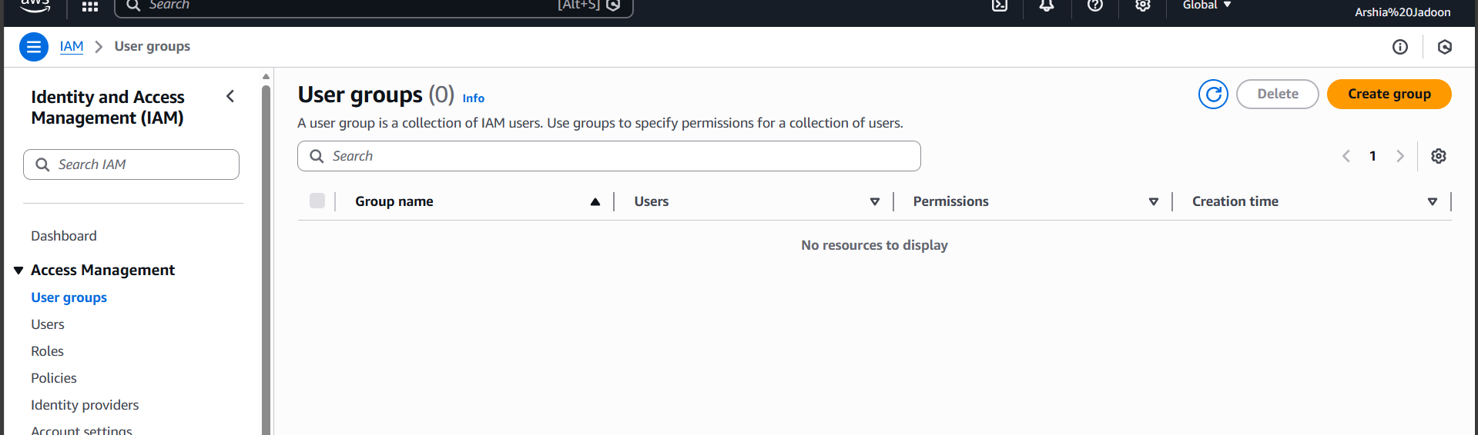

cleanup_s3_empty_state.png

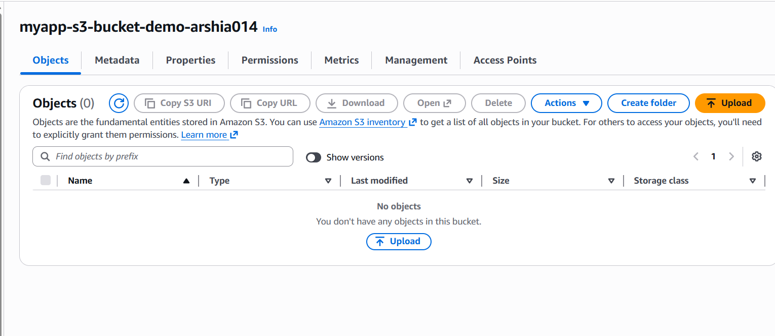

cleanup_final_files.png

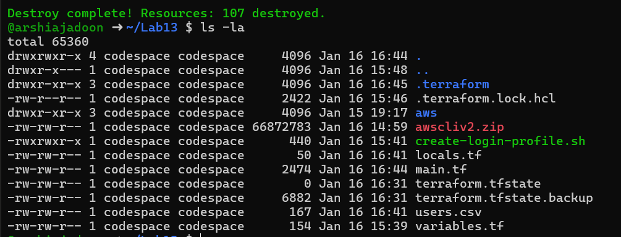

cleanup_s3_bucket_deleted.png (optional)

